Report
Task 1 – Flexbox Cards
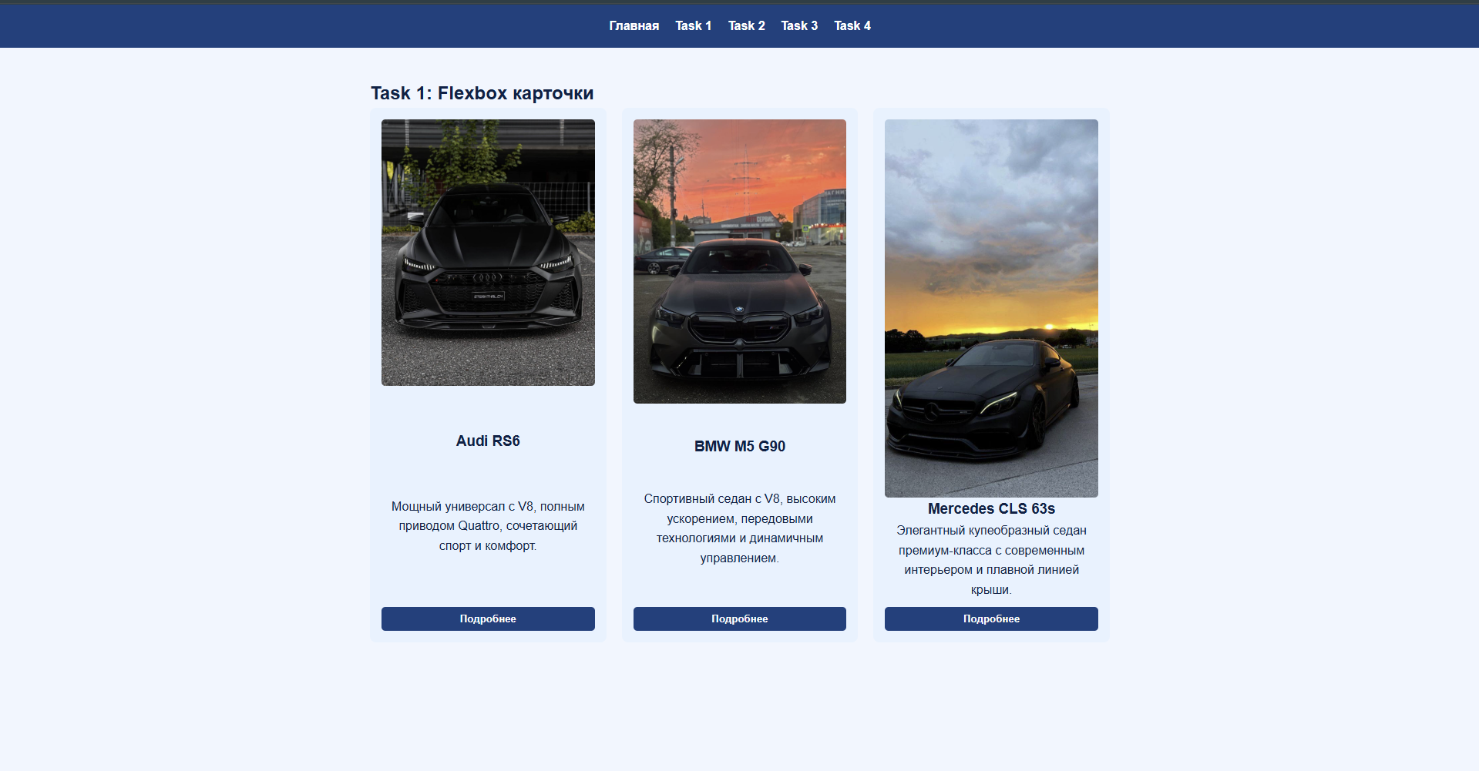
In this task, I created a container with three cards. Each card contains an image, a title, a description, and a button. The cards are arranged in a row using Flexbox. They have equal height and equal spacing between them. A hover effect (scaling and shadow) was added.
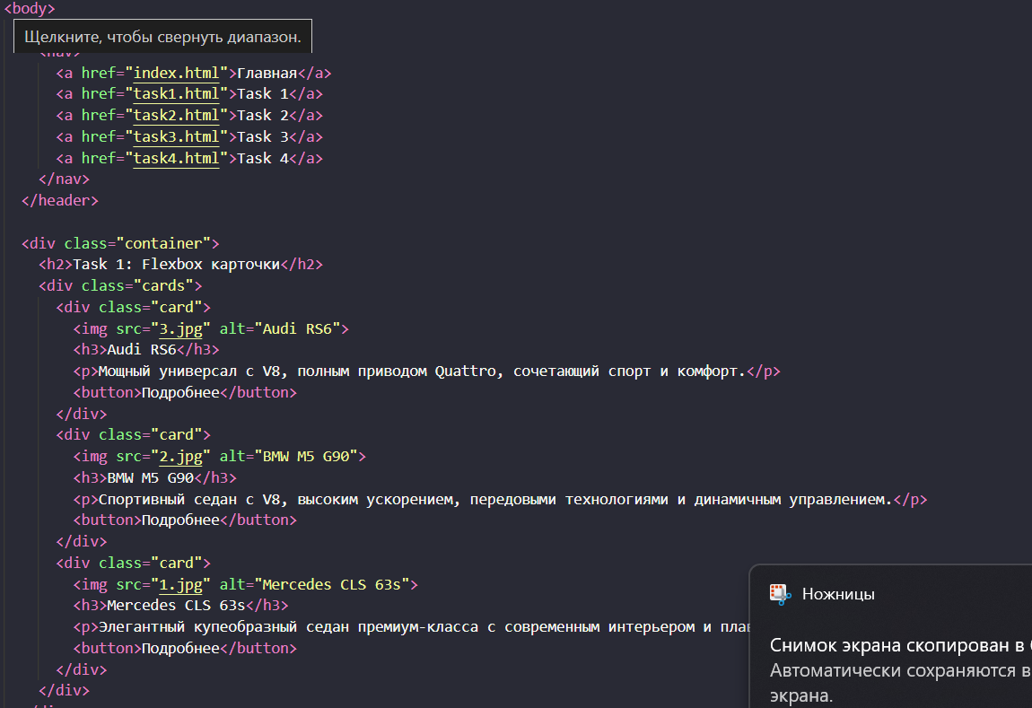

Task 2 – Grid Layout
In this task, I implemented a page layout with areas: header, sidebar, main, and footer. CSS Grid was used to arrange the elements. The header and footer span the full width of the page, the sidebar is on the left, and the main content is on the right.
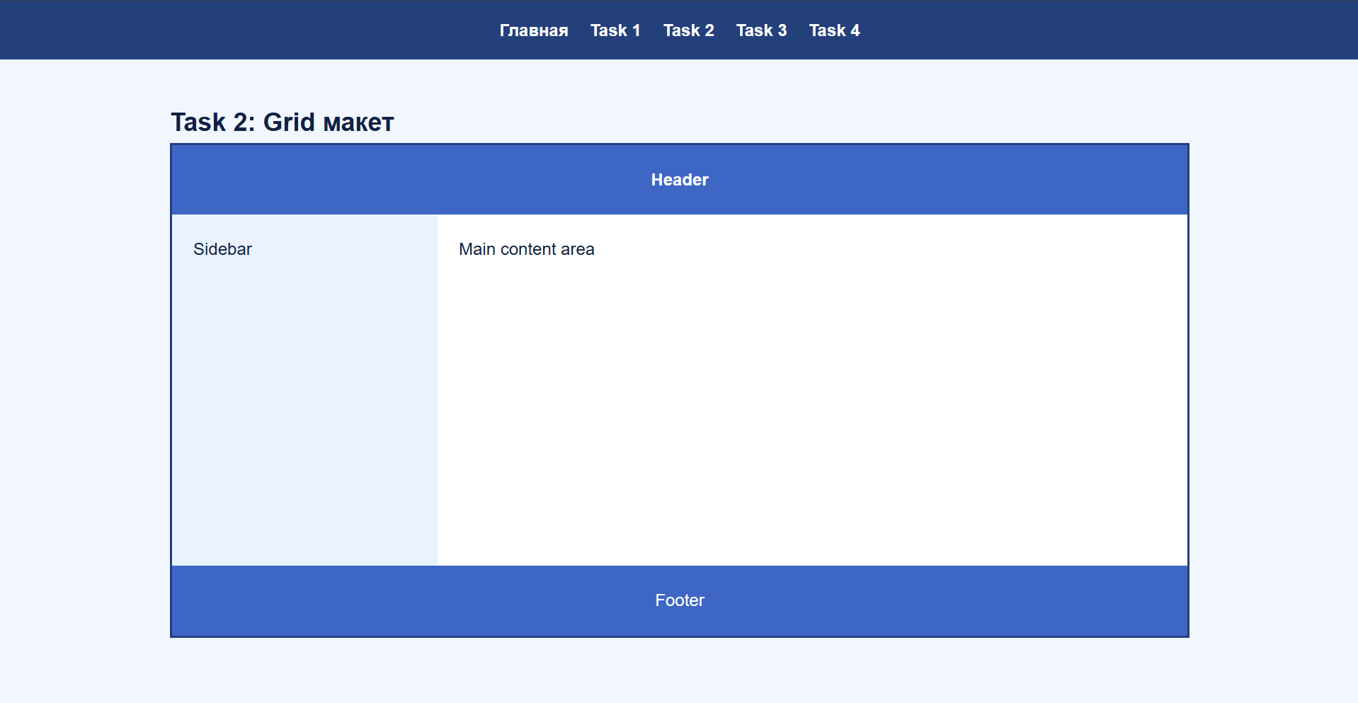
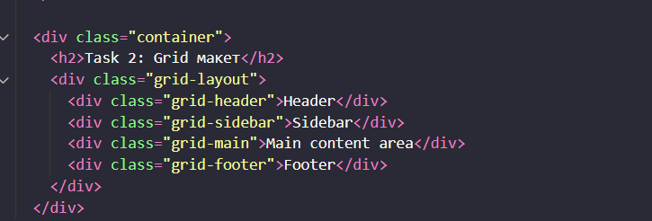
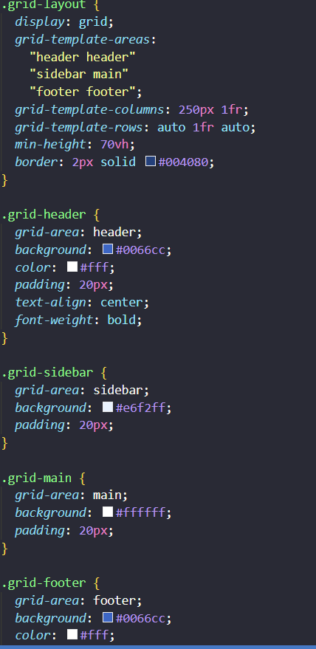

Task 3 – Image Gallery (3x3)
In this task, I created an image gallery using CSS Grid. The gallery consists of 9 images arranged in a 3×3 grid. The images have a fixed size to keep them uniform. On hover, each image slightly zooms in.
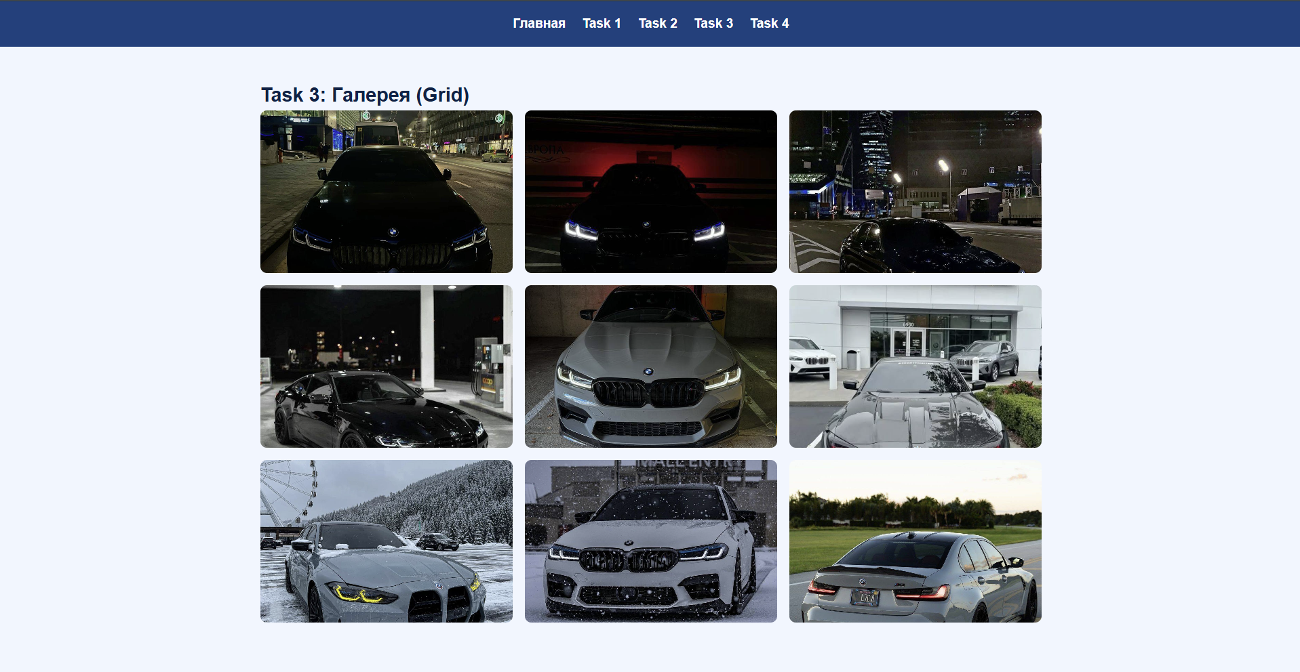
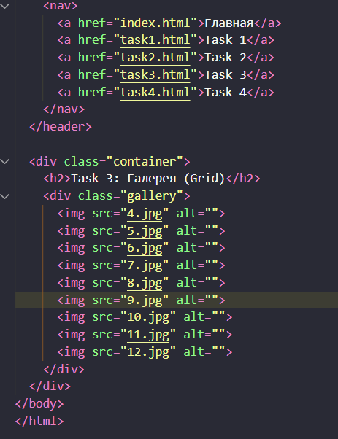
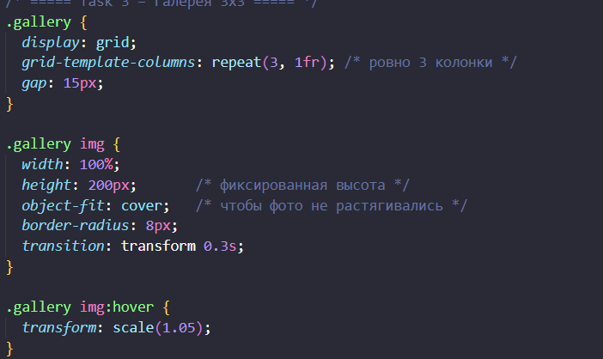
Task 4 – Portfolio Page (Flex + Grid)
In this task, I created a portfolio page using Flexbox and Grid. The header with the menu was made with Flexbox. The main part of the page is built with Grid: projects on the left, sidebar on the right. Inside the project cards, Flexbox was used to arrange text and a button. The footer spans the full width at the bottom.
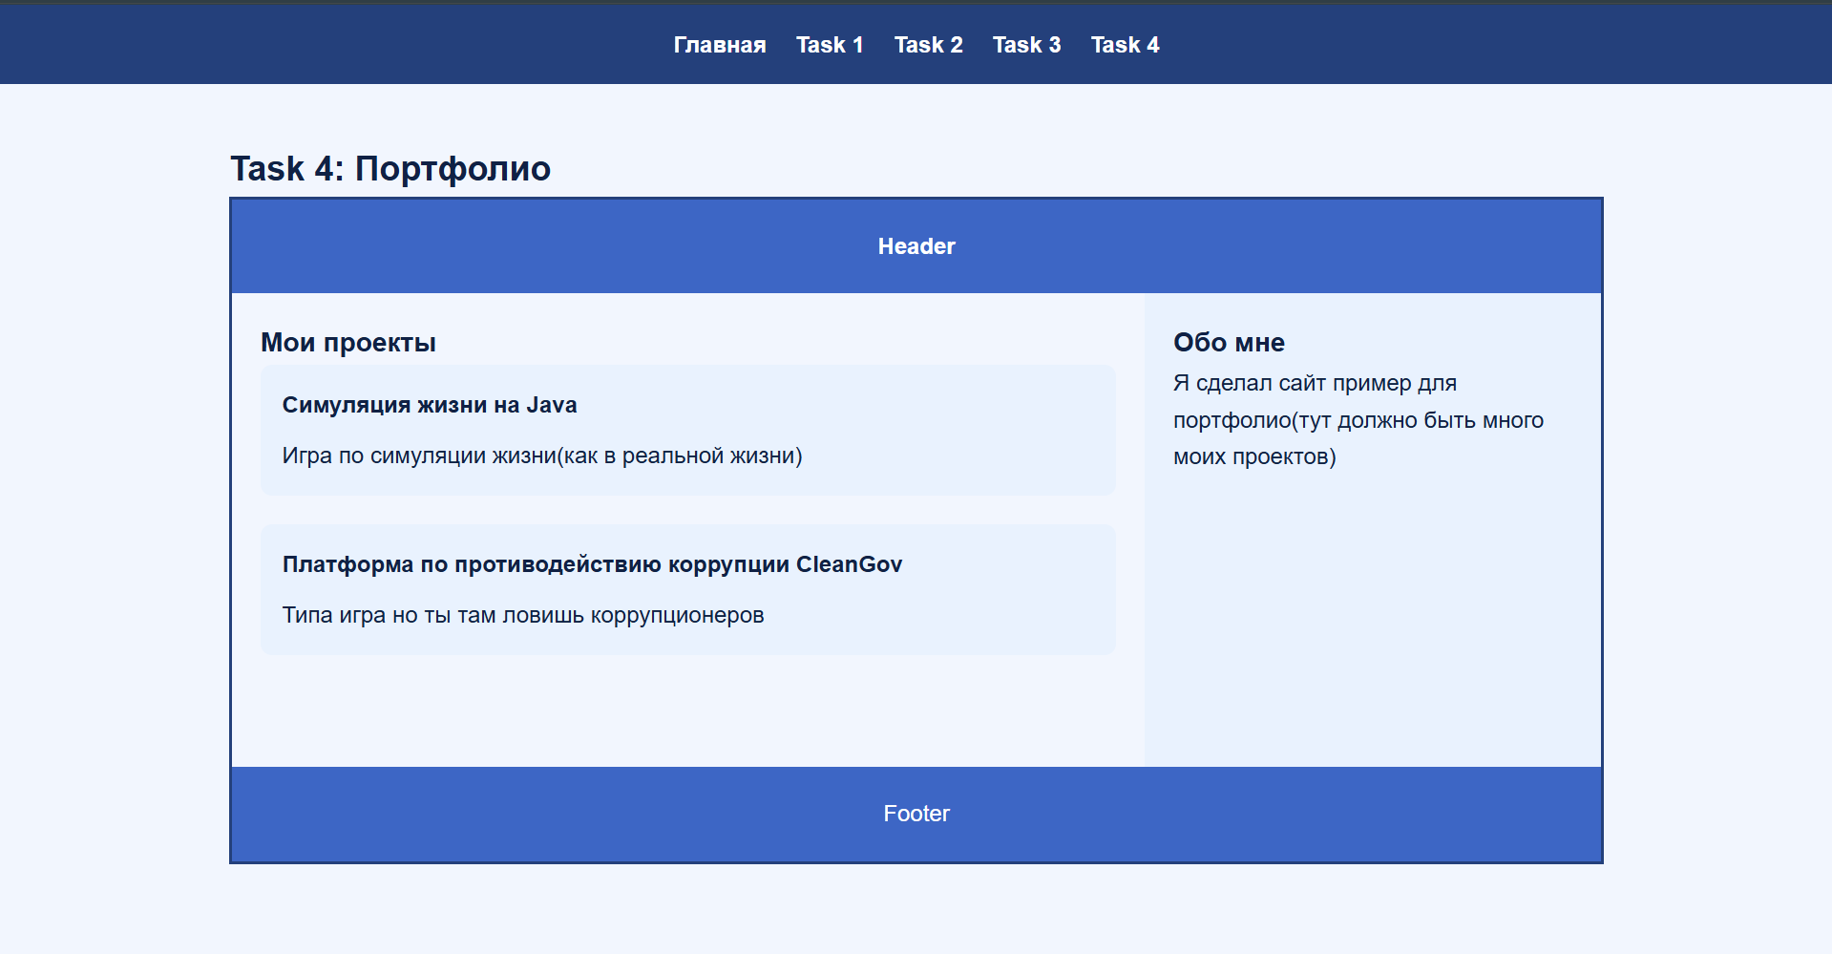
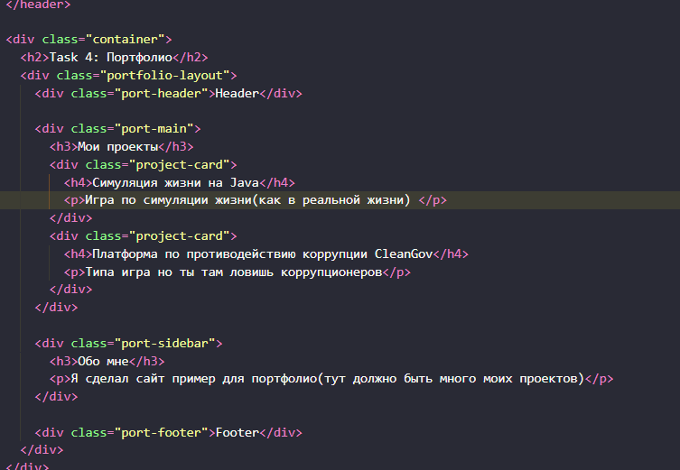
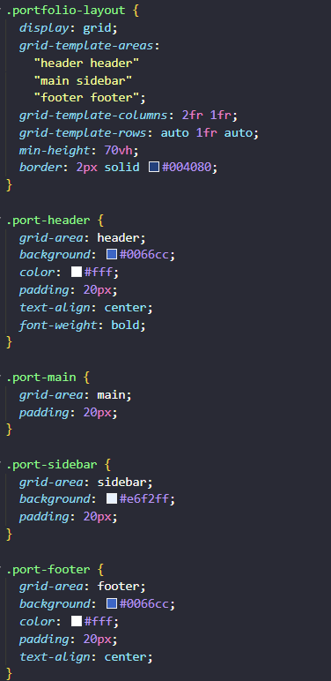
Conclusion
All tasks are completed: navigation and cards with Flexbox, a layout with Grid, a 3×3 gallery, and a portfolio page combining Flexbox and Grid. The code is written in a consistent style and designed in blue tones.
GitHub- https://github.com/XelVarful/Frontend.git

